Deer overabundance disrupt plant-pollinator networks

Abstract
Large herbivores are keystone species, so changes in their population abundance may cause cascading effects on ecosystems. Over the last decades, many species of deer (Cervidae) have experienced unprecedented densities across many areas of the Northern Hemisphere, with still unknown effects on plant-pollinator networks, an important indicator of ecosystem functioning. Our study explores the effects of increasing red deer (Cervus elaphus) densities on plant-pollinator networks of Mediterranean communities. We experimentally manipulated deer densities in large enclosures to simulate two current scenarios of deer overabundance: high densities (>30 individuals/km²) and hyper densities (>90 individuals/km²), typical of many territories, including protected areas and intensively-managed hunting estates. We compared these scenarios to an adjacent control exclosure (no deer). We found that overabundant deer scenarios reduced flower abundance of scrubs, and while flower richness decreased only in the hyper density scenario, pollinator richness decreased in both high and hyper density scenarios. Remaining plants and pollinators lost interactions, and some plants lost pollinators in the hyper density scenario. Networks became less complex and less structured: Specialization decreased because modules conformed by herbs and specialist pollinators were gradually extirpated as deer density increased. However, robustness remained unaltered,because the dominant plant was unpalatable to deer and therefore were unaffected. We conclude that in overabundant deer scenarios: 1) impact on plant-pollinator networks will increase with deer density; 2) network diversity, complexity and structurewill be eroded, especially if it is composed of palatable, rare plants, visited by specialist pollinators; and 3) network robustness will be unaffected if dominant plants are generalists and unpalatable to deer. Our study highlights the importance of plant palatability on plant-pollinator networks under herbivory, and the detrimental effect of maintaining or favouring deer overabundant populations on ecosystem functioning of Mediterranean communities.

Keywords: interaction rewiring, network modularity, network robustness, plant-herbivore interactions, plant palatability, pollinator communities, red deer, ungulate overabundance

Introduction
Large herbivores are key components of most terrestrial ecosystems, influencing several functions and associated services (Pringle et al., 2023). Particularly, large wild herbivores are known to modulate important ecosystem properties and processes, such as habitat structure, plant diversity, nutrient cycling or wildfire regimes (Huntly, 1991; Velamazán et al., 2020). However, the magnitude and direction of the effects of large herbivores on ecosystems strongly depend on their densities (e.g. Gill, 1992). This aspect is of utmost importance, as populations of wild large herbivores, particularly deer (Cervidae), have increased across Europe and North America over the past few decades (Côté et al., 2004; Carpio et al., 2021). Under this context, environmental benefits from moderate grazing (Jerrentrup et al., 2014) can be truncated in scenarios of high abundance, leading to multiple negative effects on ecosystems (Mysterud, 2006).
Red deer (Cervus elaphus) and elk (Cervus canadensis) are paradigmatic examples of unprecedented increased densities, mostly as a consequence of rural and traditional livestock abandonment, the increase of commercial and intensive hunting management, and a parallel expansion of protected land, where hunting is either limited to deer culling or prohibited (Côté et al., 2004; Bradford & Hobbs, 2008; Carpio et al., 2021). Thus, at a regional scale, overabundant deer populations can be found in natural and protected areas (Bradford & Hobbs, 2008; Apollonio et al., 2010; Borkowsky et al., 2019) as well as in commercial game estates (Azorit et al., 2012a). These increasing deer densities may negatively affect plant diversity and force vegetation to return to early stages of ecological succession (Perea et al., 2014; Borkowsky et al., 2019). Importantly, direct negative effects on plant communities may result in indirect, cascading effects on other components of the food web (Bressette et al., 2012). Ultimately, whole networks of interacting species, including plant-pollinator networks, may be affected.
Large herbivores forage selectively to meet diet requirements (Azorit et al., 2012b). In plant communities dominated by flowering species, foraging preferences may cause non-random changes in the flowering landscape (Díaz et al., 2006), and will be more pronounced as deer density increases (Sjödin et al., 2008). As a consequence, pollinator communities may show relevant changes (Kruess & Tscharntke, 2002; Lázaro et al., 2016a). Specific responses of pollinators, either negative or positive, may strongly depend on the effects on specific floral and nesting resources for pollinators (Mayer et al., 2006; Vulliamy et al., 2006). Changes in plant and pollinator communities are expected to alter plant-pollinator interactions. For instance, palatable plants affected by intense herbivory may become less attractive to pollinators and ultimately receive fewer visits from fewer pollinator species (Strauss, 1997; Gómez et al., 2009). In contrast, unpalatable plants may take advantage and monopolize pollinators or benefit from spill-over effects (Yoshihara et al., 2008; Tadey, 2015). In that situation, secondary extinctions of pollinators are expected unless they redistribute their interactions (Biella et al., 2019). Thus, in impoverished communities, plant-pollinator interactions are expected to weaken (Vázquez & Simberloff, 2003).
Plant-pollinator interactions shape complex ecological networks. Plant-pollinator networks are generalized systems (Waser et al., 1996) whose interactions are organized along a nested structure of generalist and specialist species, and in modules of strongly interacting species (Vázquez et al., 2009a). This structure can emerge from neutral processes or as a consequence of ecological relationships between species (Vázquez et al., 2009b; Dormann et al., 2017), and is intimately related to the diversity and stability of these systems (Thébault & Fontaine, 2010; Grilli et al., 2016). The few studies exploring the influence of large herbivores on network complexity and structure reached contrasting results, from negative (Guy et al., 2021; Rakosy et al., 2022), to negative/positive (Welti & Joern, 2018), positive (Vanbergen et al., 2014), with hump-shaped effects (Lázaro et al., 2016b), or without effects (Oleques et al., 2019). These diverse results arise from variations in the study systems, such as different habitats with different herbivores and plant communities leading to unique cascading effects on networks (Robinson et al., 2018; Goulnik et al., 2021). The majority of these works studied domestic livestock, and yet, no research has examined the impact of large wild herbivores on plant-pollinator networks in comparable ecological settings with similar ecological conditions and known ungulate densities.
In this work we explore the effects of increasing red deer densities on plant-pollinator communities and interaction networks (Figure S1). We conducted an unprecedented field experiment in a Mediterranean community in which we experimentally manipulated red deer densities in adjacent enclosures to simulate two current scenarios of increasing deer abundance.
We hypothesize that (1) browsing intensity will be proportional to red deer density and will differ across plant species depending on deer preferences; consequently, (2) flower abundance and richness will decrease with increasing red deer densities and, as a consequence, (3) pollinator community will be simplified. As a result, at increasing red deer densities, (4) pollinators will rewire their interactions and plants will receive fewer visits and fewer visitors; and (5) networks will be less complex, less structured, and less robust (Figure S1).

Materials and methods
Study area
The study was performed in the Valdeyernos valley, at an elevation of ca. 950 m, within the public estate of Los Quintos de Mora, located in Montes de Toledo rangeland, southcentral Iberia (Toledo province, Spain, 4°5'57.38"W, 39°26'48.57"N) (Figure S2). The climate is Continental Mediterranean, characterized by 3–5 months of dry, hot summer and high inter-annual variability of rainfall (mean annual rainfall of ~600 mm) and a mean annual temperature of ~14 ºC. The vegetation consists of a mosaic of small woodlands dominated by oak trees (Quercus ilex subsp. ballota and Q. pyrenaica) and large scrubland patches dominated by Cistus ladanifer, Rosmarinus officinalis and Erica spp. (San Miguel et al., 2011).
Red deer have been recorded in the Iberian Peninsula since the Upper Pleistocene and never disappeared from Los Quintos de Mora (San Miguel et al., 2011). Recreational human management has favoured an increase in local red deer densities (~24 deer/km²) (Peláez et al., 2018). Valdeyernos valley (~200 ha) was fenced in 2011 and had a density of ~10 deer/km², considered the sustainable natural density for these areas (e.g. Morales-Molino et al., 2019).
Novelty and importance of the manipulative experiment
Pringle et al. (2023) reviewed the experimental approaches ecologists use to study the impacts of large herbivores on terrestrial ecosystems. Exclosures are, by far, the most widely used approach. Together with translocations, these approaches can inform how herbivores or specific species affect ecosystem properties and dynamics. However, limitations arise because 1) exclosures tend to be smaller than the scale at which several ecosystem processes operate and 2) species-specific effects are difficult to isolate; in addition 3) herbivore density usually is not reported or either difficult to evaluate. In this context, Pringle et al. (2023), devise future field experiments to overcome these limitations and gain insight on the relationship between large herbivores and ecosystem processes. They propose large plots (which often is detrimental for spatial replication, e.g. in comparison with several small exclosure plots) combined with experimental manipulation of specific herbivores at known densities (Pringle et al. 2023). Here we describe, to our knowledge, the first large wild herbivore manipulative experiment with increasing deer densities, consisting of comparable hectare-scale enclosures in a Mediterranean ecosystem.
Experimental setup and red deer introduction
We installed an enclosure encompassing ~17 ha, which was divided into 3 sub-enclosures (7.4, 7.1 and 2.6 ha) separated by 2 m high wire fences (Figure S2). All enclosures have similar environmental features and contain a similar proportion of the vegetation types (oak forests and scrublands). The analyses of the vegetation surveys from May-June 2020 showed that both floristic composition and cover of plant communities were similar among enclosures (Cuerdo et al., submitted). Because our observation units are flowers, this information allowed us to associate direct and cascading changes in the enclosures to the effects of the experiment. Fences were erected in October-November 2020. We experimentally manipulated red deer densities by introducing young female individuals (yearlings) of red deer. Introduction was carried out on March 16th 2021, with no supplementary feeding.
We recreated three scenarios of contrasted herbivory, one per enclosure (thereafter treatments), namely: high density (6-7 young female deer, 81-95 ind/km², equivalent to 55-63 deer/km² of a standard population with 1/1 sex ratio of all ages; Peláez et al., 2017) and hyper density (9-12 young female deer, 127-169 indr/km², equivalent to 90-113 deer/km² of a standard population) (Figure S2), and the control enclosure (no deer). ). The control recreates a management scenario commonly used to preserve vegetation in protected areas. The high density treatment mimics the situation of many natural areas from Iberia (> 30 deer/km²; Vicente et al., 2007; Perea et al, 2014), central Europe (Borkowski et al., 2019) or other areas of America where red deer have been introduced (Charro et al., 2018). The hyper density treatment simulates a typical commercial and intensively-managed game estate of Central and Southern Iberia (> 90 deer/km²; Azorit et al., 2012a; Acevedo et al., 2008). These high and hyper densities of deer are also common in North America for white-taile deer (Odocoileus virginianus) (Kie & Bowyer, 1999; Williams et al., 2013).

Herbivory and pollinator surveys
he magnitude of the experiment prevented us from generating spatial replicates (As stated before). That is, we have one truly independent plot -enclosure- per treatment. However, in order to address our questions while maintaining scientific rigor, we included as much variability as possible, following these spatio-temporal replications: 1) we set three transects per treatment; and 2) we surveyed each treatment for three days. Thus, in each enclosure we established three 50 m transects , 2 m wide (Figure S2),located within the scrubland (N-S direction). The set of transects encompass all the floral variability present in the enclosure (abundant, patchy-distributed, and rare species), while maximizing the independence among treatments. Main floral resources in the study period included Cistus ladanifer (dominant woody species according to our woody plant species coverage and flower surveys, Table SX), C. populifolius (Cistaceae) and Thymus mastichina (Lamiaceae) (subdominant species Table SX). C. ladanifer presented a dense, continuous distribution along the scrubland, whereas C. populifolius and T. mastichina had scattered individuals in patches. These three species (including all their individuals) will be hereafter referred to as focal plants. Because of the process studied, plants and pollinators of the transects make up a single community, so for each survey, data from the three transects were pooled together.
We surveyed at the flowering peak of C. ladanifer, which lasts about 14 days, from May 17th to May 26th 2021 -1 survey/day during 9 days-. We sampled each enclosure in three non-consecutive days (three days span from one survey to another), 9 surveys in total. Sampling was carried out between 9 am to 3 pm and under optimal and consistent weather conditions for pollinator activity. We therefore generated three replicates per treatment based on the fact that: 1) temporal variability was very high, i.e., flower communities from the same enclosure were very different from one day to another, with ~75% variation in the abundance of the dominant flowering plant, and ~40% variation in flowering species richness, and 2) because Cistus spp. flower life-span is 1 day (e.g. Talavera et al. 1993), flower resampling among surveys was minimal.
In the first survey of each enclosure, deer herbivory on all focal plants was evaluated. Ten individuals of each focal plant evenly distributed along each transect were selected, and the browsing degree of each individual (30 in total) was measured following Perea et al. (2015), with a semiquantitative measure of herbivory that ranges from 0 (no browsing evidence) to 5 (maximum browsing intensity).
In each survey we quantified the number of flowers of all plant species along each transect. Pollinator surveys consisted of several rounds (range 4-6 rounds). In each round we walked along the transect, recording all pollinators contacting the reproductive organs of the flowers. To record an adequate number of interactions, rare plant species were surveyed more frequently. Pollinators were identified to the lowest taxonomic rank possible. Some specimens were captured for later identification in the laboratory, where they were either identified to species level or separated into morphospecies of higher taxonomic ranks.
We standardized the information of pollinator surveys and calculated pollinator abundance based on visitation rates and interaction frequencies. The visitation rate was calculated as the number of pollinators recorded on a plant species divided by the number of flowers surveyed of the plant. Interaction frequency was calculated as the visitation rate of each pollinator to a plant species multiplied by the number of flowers of the plant. The abundance of a pollinator is the sum of all the interaction frequencies in which it is involved.

Data analysis
1. Herbivory. – We compared browsing degrees of focal plants between treatments using cumulative link models (CLMs) for ordinal regression. We performed a model for each focal plant, with browsing damage as a response variable and treatment (high, hyper or control density) as the predictor.
2. Plant community. – To compare plant communities among treatments we analyzed overall flower abundance of the community (log-transformed) and the flower abundance of each focal plant (for C. populifolius data was log-transformed). Because for C. populifolius and T. mastichina the number of individuals differed between treatments, we standardized the number of flowers by the number of individuals. We also calculated flower richness (log-transformed), diversity (Shannon index) and evenness (Hurlbert’s PIE index; Hurlbert, 1971), as well as plant composition. Flower abundance and diversity variables were analyzed with ANOVA followed by posthoc Tukey’s tests. Composition was analyzed with PERMANOVA, using the Bray-Curtis dissimilarity index on square root transformed data, followed by pairwise comparisons (Martinez Arbizu, 2020) and SIMPER analyses (to detect which species differed between treatments). In all analyses treatment was used as a fixed factor. Flower diversity and evenness were analyzed with Kruskal-Wallis tests.
3. Pollinator community. - To compare pollinator communities among treatments we analyzed overall pollinator abundance, richness, diversity (Shannon index) and evenness (Hurlbert’s PIE), as well as pollinator composition. Richness was calculated through individual-based rarefaction curves following Chao and Chiu (2016). Sample coverage was > 95% for all communities We followed this approximation because pollinator diversity was very high and some detected species are particularly rare. For statistical comparisons we used the same statistical methods as for plant community analysis. Because pollinator abundance and richness were not statistically related to flower abundance and richness, respectively (F_{1,7} = 0.16, P = 0.70; F_{1,7} = 3.03, P = 0.12), we discarded flower information as covariates in the analyses. Pollinator abundance and evenness were analyzed with Kruskal-Wallis tests.
4. Plant-pollinator interactions. – We built a plant-pollinator network with interaction frequency data from each plant-pollinator survey. These networks were built upon more than 7000 interactions between 13 plant and 158 pollinator species, comprising 327 distinct interactions.
To evaluate how plants and pollinators redistribute their interactions among treatments, we calculated interaction dissimilarity following Noreika et al. (2019). We calculated ꞵ_{OS}, i.e. the interaction dissimilarity considering the subset of shared species of two networks. We used quantitative data from interaction frequencies and the Ruzicka index of dissimilarity. The quantitative approximation is particularly interesting in this study because, as red deer density increases, flowers of some plants become less abundant, causing important changes in pollinator foraging decisions (true rewiring), a decrease in interaction frequency for these plants (also measured as rewiring), and a net loss of interactions (richness component). We calculated ꞵ_{OS} between pairs of local networks within the same treatment and across treatments. We compared ꞵ_{OS} using beta regression models (link = logit). Model significance was assessed with Wald tests, and we calculated least-squares means for multiple comparisons between treatments.
For focal plants, we calculated visitation rate and generality for each network. Generality is the weighted mean number of pollinator species visiting a plant species. For pollinators, we calculated the generality of the whole trophic level. We compared these variables among treatments with ANOVA followed by posthoc Tukey’s tests.
5. Network structure
To compare plant-pollinator network structure among treatments, we calculated several network metrics from each local network of each treatment: network size (log-transformed) (sum of interacting species of plants and pollinators), interaction richness (number of distinct plant-pollinator interactions), interaction diversity (Shannon diversity index of interactions), interaction evenness (Shannon evenness index of interactions), network connectance (weighted quantitative proportion of realized interactions; Bersier et al., 2002), network specialization (H₂’; Blüthgen et al., 2006), network nestedness (WNODF; Almeida-Neto & Ulrich, 2011), network modularity (Q) and number of network modules (nQ) (Dormann & Strauss, 2014), and network robustness (area below the secondary extinction of pollinators curve produced after the extinction of plants, with least abundant going extinct first; Memmot et al., 2004; Burgos et al., 2007).
For each network, we assessed the significance of nestedness and modularity with null models, generating 1000 random networks with algorithms from Vázquez et al. (2007) and Patefield (1981), respectively. The observed values were compared with the 95% confidence interval of the null distribution, and z-scores were used to evaluate whether the observed structure differed from a random organization.
We compared these variables among treatments with ANOVA followed by posthoc Tukey’s tests. Network connectance and number of modules were analyzed with Kruskal-Wallis tests (followed by posthoc Dunn’s test). Because all network metrics can be influenced to some extent by network size (Dormann et al., 2009), we repeated these analyses including network size as a covariate.
To visualize patterns in network structure we generated a bipartite and a modular meta-network for each treatment, built from the three local networks per treatment.
Software
All analyses were performed in R-4.2.3 (R Core Team, 2023). We used the ordinal package (clm function) (Christensen, 2022) for cumulative linear models (CLMs); iNEXT (Hsieh et al., 2022) for rarefaction curves; vegan (Oksanen et al., 2022) for multivariate statistics; betalink (Bartomeus, 2019) for interaction dissimilarity; betareg (Zeileis et al., 2022) for beta regression models; emmeans (Lenth et al., 2023) for multiple comparisons; and bipartite (Dormann et al., 2022) for network analyses.

Results
1. Herbivory
Cistus ladanifer was not affected by red deer density (X²₂ = 2.19, P = 0.33) (Figure 1a). In contrast, C. populifolius (X²₂ = 84.4, P < 0.01) and Thymus mastichina (X²₂ = 33.9, P < 0.01) suffered from greater deer browsing in the Hyper density treatment (Figure 1b-c).
2. Plant community
Deer density did not affect overall flower abundance of the community (F_{2,6} = 2.4, P = 0.17), but affected flower abundance of some focal plants (Figure 1d-f). While Cistus ladanifer was unaffected (F_{2,6} = 0.07, P = 0.93), C. populifolius had fewer flowers per individual in the High and Hyper density treatments compared to the Control treatment (F_{2,6} = 13.89, P = 0.006; Tukey’s P < 0.05). Furthermore, Thymus mastichina had fewer flowers per individual in the Hyper density treatment compared to the Control and High density treatments (F_{2,6} = 13.42, P = 0.006; Tukey’s P < 0.05) (Figure 1d-f).

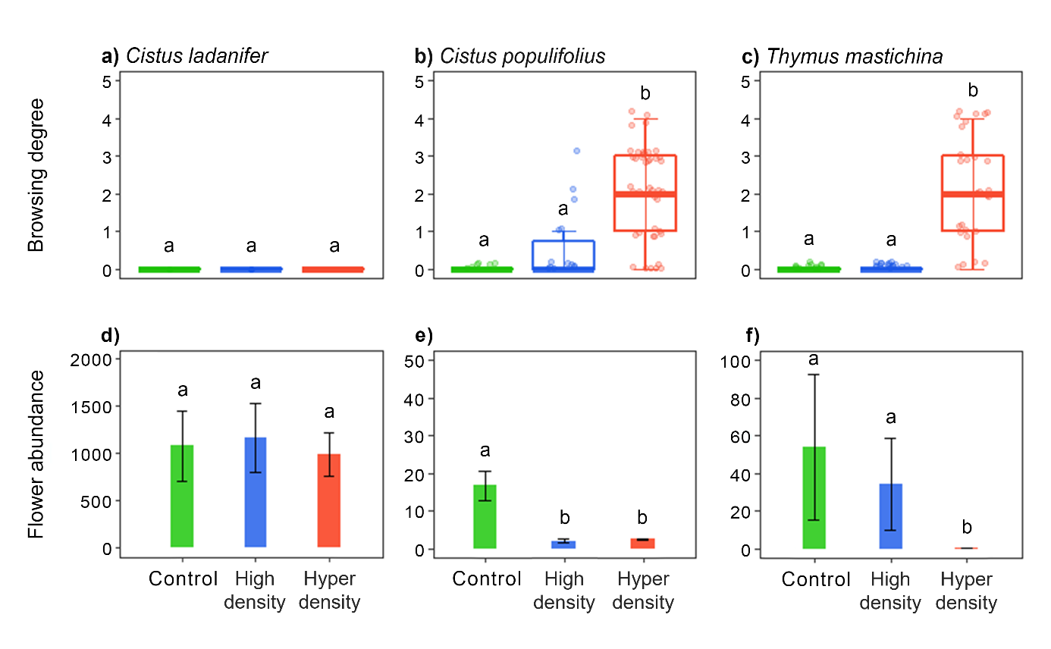
Figure 1. Browsing degree (a-c) and flower abundance (d-f) of each focal plant species in Control (green), High density (blue), and Hyper density (red) treatments. For Cistus populifolius and Thymus mastichina, the number of flowers is standardized by the number of individuals (see Material and Methods). Different letters above the bars indicate significant (P < 0.05) differences between deer density treatments.

Deer density affected flower richness (F_{2,6} = 6.16, P = 0.035). Hyper density treatment had 1.9-fold fewer flowering species than the Control treatment (7±0 vs 13±2, Tukey’s P = 0.03). Deer density did not affect flower diversity (X²₂ = 3.82, P = 0.15) nor flower evenness (X²₂ = 4.62, P = 0.1). Deer density affected plant composition (F_{2,6} = 5.99, P = 0.019). The Hyper density treatment had different plant composition compared to the Control (F_{1,4} = 11.30, P < 0.05) and High density (F_{1,4} = 10.13, P < 0.05) treatments. In the Hyper density treatment, the herbs Tuberaria guttata (Cistaceae) (vs Control and High density treatments), Crepis spp. and Tolpis spp. (Asteraceae) (vs Control treatment) were not found, and the scrub Rosmarinus officinalis (Lamiaceae) (vs Control treatment) was less abundant (SIMPER, contribution to similarity > 5%, P < 0.05).
3. Pollinator community
Deer density did not affect overall pollinator abundance (X²₂ = 5.42, P = 0.07). However, pollinator richness changed across treatments (F_{2,6} = 5.45, P = 0.045). High and Hyper density treatments had 1.3-fold less pollinator species than the Control treatment (75±3 and 77±37 vs 96±3 pollinator species). Deer density affected pollinator diversity (F_{2,6} = 6.56, P = 0.031). The Hyper density treatment had 1.2-fold less pollinator diversity than the Control and the High density treatments (3.55±0.14 vs 4.16±0.21 and 4.32±0.10 bits). Deer density did not affect pollinator evenness (X²₂ = 5.07, P = 0.08). Deer density affected pollinator composition (F_{2,6} = 2.20, P = 0.015). Thus, the Hyper density treatment had different pollinator composition compared to the Control (F_{1,4} = 2.28, P < 0.05) and High density (F_{1,4} = 3.01, P < 0.05) treatments. SIMPER analyses revealed no important changes in contribution to similarity of species between treatments.
4. Interaction patterns
Deer density did not affect interaction dissimilarity (ꞵ_{OS}) involving Control networks (X²₂ = 4.76, P = 0.093). In contrast, deer density affected ꞵ_{OS} involving both High (X²₂ = 36.27, P < 0.001) and Hyper density (X²₂ = 6.94, P = 0.031) networks. In both cases, local networks of High and Hyper density treatments presented lower ꞵ_{OS} when compared to network pairs involving both treatments (High-High vs High-Hyper, z = -5.11, P < 0.001; Hyper-Hyper vs High-Hyper, z = -2.13, P = 0.028). The importance of interaction richness to rewiring for interaction dissimilarity increases as deer density increases (Figure S3).
Deer density did not affect visitation rate of any focal plant (F_{2,6} < 1.46, P > 0.30) (Figure 2a-c). Deer density did not affect generality of Cistus ladanifer and C. populifolius (F_{2,6} < 4, P > 0.08) (Figure 2d-e), but affected generality of Thymus mastichina (F_{2,6} = 11.22, P = 0.009). T. mastichina had lower generality in the Hyper density treatment than in the Control treatment (Tukey’s P = 0.008) (Figure 2f). Pollinator generality was unaffected by deer density (F_{2,6} = 1.14, P = 0.38).
5. Network structure
Deer density did not affect network size, interaction richness or interaction diversity (Table 1). However, deer density affected interaction evenness. Thus, the Hyper density treatment showed lower interaction evenness than the High density treatment (Table 1). Similarly, the High density treatment showed higher network connectance than the Control and the Hyper density treatments (Table 1). Finally, the Hyper density treatment had lower network specialization than the Control and the High density treatments (Table 1). Most results were identical when network size was included as a covariate (Table 1). Bipartite meta-networks from each treatment are shown in Figure 3.
All networks were significantly less nested and more modular than random (Table S1). The Hyper density treatment had the least structured networks as presented the lowest z-scores among networks (Table S1). The Hyper density treatment also showed higher nestedness than Control and High density treatment and lower modularity than the Control treatment (Table 1). Hyper and High density treatments had lower numbers of modules than the Control treatment (Table 1). Most of these significant differences
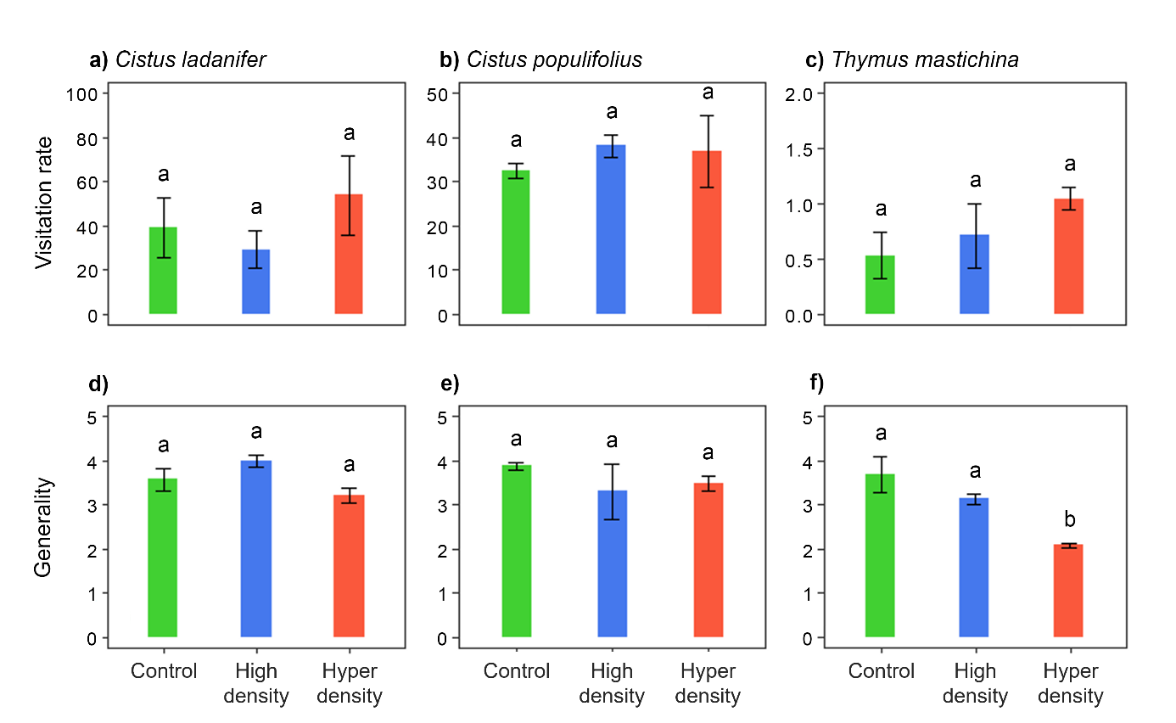
Figure 2. Visitation rate (a-c) and generality (d-f) of each focal plant species in Control (green), High density (blue), and Hyper density (red) treatments. Different letters above the bars indicate significant (P < 0.05) differences between treatments.

disappeared when network size was included as a covariate (Table 1). Deer density did not affect network robustness (Table 1).
All treatments had a module characterized by frequent interactions between Cistus ladanifer and beetles (mainly Heliotaurus gr. ruficollis), medium-sized flies (mostly Anthomyiidae) and ants (Camponotus cruentatus among others) (Figure 4). The Control treatment had two exclusive modules: one characterized by frequent interactions between C. populifolius and short-tongued small bees (Lasioglossum spp.) and ants (mainly Iberoformica subrufa), and another conformed by Thymus mastichina and nomad bees (Nomada spp.) and tachinid flies (Tachinidae) (Figure 4). In the High density treatment these two modules merged together. In the Hyper density treatment, the T. mastichina module weakened (interaction frequency decreased and the plant
Table 1. Measures of network structure in Control, High density (High), and Hyper density (Hyper) networks (N = 3 per treatment). Model 1 = ANOVA (treatment as fixed factor); Model 2 = ANCOVA (network size as covariate).
Network metric | Control | High Density | Hyper Density | Model 1 |  | Contrasts | Model 2 |  | Contrasts
 | mean ± SE | mean ± SE | mean ± SE | F_{2,6} | P | Tukey's P < 0.05 | F_{2,5} | P | Tukey's P < 0.05
Network size | 76.7 ± 5.9 | 63.3 ± 0.33 | 65 ± 4.16 | 2.94 | 0.13
Interaction richness | 115 ± 13.1 | 85.7 ± 8.17 | 91.7 ± 4.18 | 2.81 | 0.14 |  | 0.13 | 0.88
Interaction diversity | 3.4 ± 0.18 | 3.37 ± 0.14 | 2.97 ± 0.04 | 3.26 | 0.11 |  | 4.89 | 0.067
Interaction evenness | 0.72 ± 0.02 | 0.76 ± 0.02 | 0.66 ± 0.01 | 9.35 | 0.014 | Hyper < High | 13.71 | 0.009 | Hyper < High
Connectance (weighted) | 0.085 ± 0.001 | 0.12 ± 0.007 | 0.089 ± 0.002 | 6.49* | 0.039 | High > Control | 14.21 | 0.009 | High > Control, Hyper
Specialization (H₂') | 0.55 ± 0.03 | 0.59 ± 0.03 | 0.29 ± 0.02 | 33.09 | < 0.001 | Hyper < Control, High | 34 | 0.001 | Hyper < Control, High
Nestedness (WNODF) | 23.3 ± 1.6 | 23.7 ± 1.9 | 30.9 ± 0.45 | 8.76 | 0.017 | Hyper > Control, High | 9.05 | 0.022 | Hyper > High
Modularity (Q) | 0.34 ± 0.05 | 0.29 ± 0.05 | 0.16 ± 0.003 | 5.62 | 0.042 | Hyper < Control | 3.94 | 0.094
Module number (nQ) | 6 ± 0 | 4 ± 0 | 4 ± 0 | 8* | 0.018 | Hyper, High < Control | NA‡ | NA | NA
Robustness | 0.73 ± 0.004 | 0.72 ± 0.02 | 0.67 ± 0.04 | 1.93 | 0.23 |  | 1.24 | 0.37
*Kruskall Wallis - Dunn's tests
‡ unreliable result as variance is 0

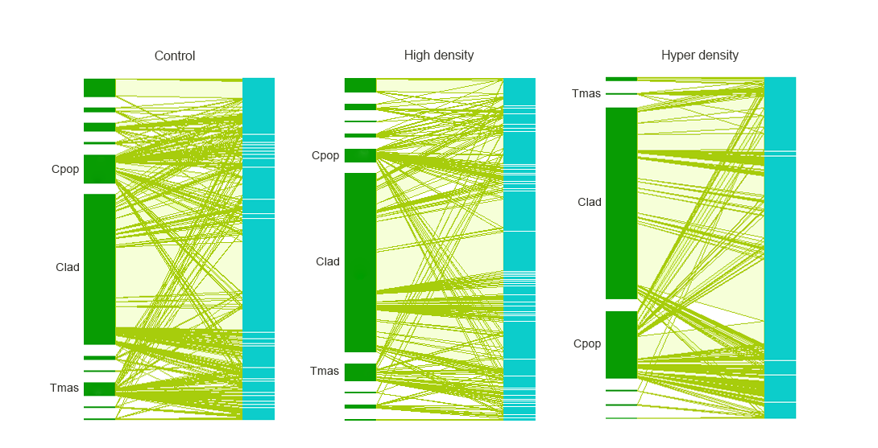
Figure 3. Bipartite meta-network of Control, High density, and Hyper density treatments (N = 3 local networks per treatment). Plants are represented in dark green and pollinators in sky blue. Focal plants are indicated (Clad, Cistus ladanifer; Cpop, Cistus populifolius; Tmas, Thymus mastichina). Link (pale green) thickness indicates the frequency of interactions between plants and pollinators.

became trivial within the module; Figure 4). The Control treatment had two more exclusive modules characterized by frequent interactions between Crepis spp. and Tolpis spp. (Asteraceae) and the pollen specialist Panurgus calcaratus (Andrenidae), and between Campanula lusitanica (Campanulaceae) and Usia spp. (Bombyliidae) (Figure 4). In the High density treatment these modules weakened and merged together whereas in the Hyper density treatment disappeared (Figure 4).

Discussion
In this study we have evaluated the effect of increasing red deer densities on plant-pollinator networks. We found that by grazing and browsing red deer extirpated several herbs and reduced the number of flowers of abundant scrubs, originating
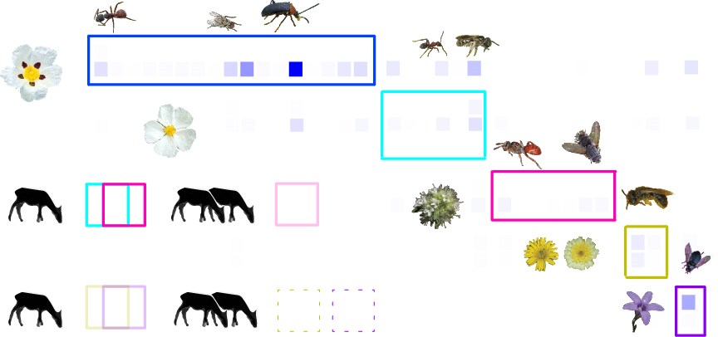
Figure 4. Modular meta-network of the Control treatment (N = 3 local networks), with schematic representation of patterns when compared with meta-networks from High (one deer) and Hyper (two deer) density treatments. Each module is coloured differently, and colour intensity within modules denotes interaction frequency. For clarity, we omitted several weak interactions and only the most connected plants (in rows) and pollinators (in columns) are represented. Dark blue module: Cistus ladanifer – Camponotus cruentatus / Anthomyiidae / Heliotaurus gr. ruficollis; sky blue module: Cistus populifolius – Iberoformica subrufa / Lasioglossum spp.; pink module: Thymus mastichina – Nomada spp. / Tachinidae; yellow module: Crepis spp. / Tolpis spp. – Panurgus calcaratus; violet module: Campanula lusitanica – Usia sp. Overlapping modules: modules merged together; pale coloured module: module weakened; dashed lined module: module disappeared. See text for details.

a decrease in pollinator richness. Remaining plants and pollinators tended to lose interactions, and some plants lost pollinators. Networks become less complex and less structured, but paradoxically in some cases simplification may confer stability. Network specialization decreased because associations between herbs and specialist pollinators were gradually extirpated as red deer density increased. In spite of this, network robustness remained unaltered, apparently because dominant plants were little affected by red deer.
1. Browsing degrees
We found that some plants were affected by browsing, but only at the highest densities. This is in accordance with Gill (1992), and suggests a density threshold between High and Hyper density of deer (at ~60 deer/km²) above which most plants are negatively affected by deer browsing. Cistus ladanifer was not significantly affected by deer, probably because it is unpalatable to deer (Fernández-Olalla et al., 2006; Perea et al., 2014) and highly abundant, which provides a low-quality abundant food source. However, the unpalatable and subdominant Thymus mastichina was affected by browsing. Thus, feeding on T. mastichina might be influenced by the vegetation context under an overabundance scenario (Mobæk et al., 2009). This might be especially likely in the Hyper density treatment, where the scarcity of palatable plants may result in browsing on unpalatable species (Borowski et al., 2021).
2. Plant communities
The abundance of focal plants was reduced proportionally to deer density. However, the plant community changed mainly by the extirpation of several herbs at the Hyper density treatment. This result can be explained by two complementary mechanisms. First, red deer avoided the dominant and unpalatable flowering species (Cistus ladanifer), so overall floral resources and the community structure were unaffected, as seen in landscapes dominated by unpalatable species (e.g., Augustine & McNaughton, 1998). Second, red deer foraged preferentially on herbaceous plants and when herbs became rare or disappeared, they increasingly incorporated scrubs into their diet (Azorit et al., 2012b). Feeding on relatively rare species not tolerant to herbivory can therefore cause a rapid simplification of the flowering plant community (Mysterud, 2006).
3. Pollinator communities
Pollinator communities paralleled those changes caused in plant communities by increasing deer densities. As such, pollinator richness was reduced in the Hyper density treatment, but also in the High density treatment, where flower richness was unaffected. This situation is likely in a scenario where flower numbers are reduced due to herbivory, reducing floral display and therefore pollinator attraction (Thompson, 2001). Indeed, the simplification of the pollinator community also involved a reduction in species diversity, probably because relatively abundant pollinators found in relatively rare flowers (which disappeared in the Hyper density treatment) declined.
4. Interaction patterns
Interaction dissimilarity increased only from High to Hyper density treatment. An increase in interaction dissimilarity is expected for contrasting disturbed systems, as simplified environments may contain fewer pollinator species, mainly generalists, which are more prone to rewire (Lázaro & Gómez-Martínez, 2022). Indeed, flower abundance is determinant for the realization of plant-pollinator interactions (Carstensen et al., 2014; CaraDonna et al., 2017), and therefore red deer herbivory may prevent pollinators from interacting with affected plants.
Although deer browsing affected Cistus populifolius and Thymus mastichina and therefore the number of flowers per individual decreased, the visitation rate was unaffected. That means that pollinators are distributed proportionally to floral resources, following an ideal-free distribution (Fretwell & Lucas, 1970). However, and because the abundance and richness of pollinators are usually positively related (e.g. Lázaro et al., 2016a), generality of T. mastichina was reduced. High browsing levels in the Hyper density treatment led T. mastichina floral display to the minimum representation (few flowers per individual). In addition, the restricted pollination system of T. mastichina may constrain pollinator visitation to affected individuals (Stang et al., 2006). Because the diversity of pollinators is usually positively related to pollination function (e.g. Albrecht et al., 2012), this situation may negatively affect the reproductive success and therefore the long-term persistence of T. mastichina in the local community (Hernández-Castellano et al. in prep.).
5. Network structure
Interaction evenness and network connectance peaked in the High density treatment. These variables are positively related to system function and stability (Dunne et al., 2002; Devoto et al., 2012; but see Vieira & Almeida-Neto, 2014), and have been detected to increase in two scenarios: when herbivores prevent the dominance of a few plant species, or when herbivores indirectly increase floral resources, attracting pollinators to the community and generating new interactions (Vanbergen et al., 2014; Lázaro et al., 2016b). However, in our study system, stability might be related, on the one hand, to the simplification of the system from Control to High density treatment (reduction in the frequency of strong interactions involving specialist species), and, on the other hand, to the restoration of complexity from Hyper to High density treatment (fewer dominant interactions).
Network specialization decreased in the Hyper density treatment as a consequence of the extirpation of herbaceous plants and their associated specialist pollinators. Thus, the loss of unexpected interactions may have caused an increase in nestedness. Nevertheless, the Hyper density treatment showed the least structured networks, probably because resource constraints may induce pollinators to compete for floral resources, resulting in missing expected interactions (Dormann et al., 2017). Because network size seems to explain some differences in network nestedness between deer density treatments, high network nestedness may be reached in impoverished systems simply by partner constraints (Vázquez et al., 2007; Vázquez et al., 2009b). Therefore, the stability provided by high network nestedness (e.g. Thébault & Fontaine, 2010) might be, again, the consequence of the simplification of the system.
Network modularity decreased only in the Hyper density treatment, but the number of network modules decreased in both the High and Hyper density treatments. This gradual simplification in network modularity as deer density increases can be explained because: 1) the module conformed by the dominant plant, Cistus ladanifer, was unaffected as deer avoided the plant; 2) the modules conformed by the subdominant plants, C. populifolius and Thymus mastichina, were maintained, but simplified proportionally to deer browsing; 3) the modules conformed by herbaceous plants and associated specialist pollinators were simplified in the High density treatment and extirpated in the Hyper density treatment, as grazing increased with deer density. Modularity patterns vanished when network size was taken into account, suggesting that the effect of deer density on modularity was mediated exclusively by the extirpation of plants and, most probably, the secondary extinction of related pollinators. Thus, the general structure of networks may be resistant to red deer overabundance provided it is composed by unpalatable or relatively abundant flowering plants (Oleques et al., 2019). In contrast, it may be vulnerable if it is composed by palatable, relatively rare flowering species which are visited by specialist pollinators (Rakosy et al., 2022). In that latter situation, even in ecosystems with relatively low herbivore densities, ecological and evolutionary dynamics resulting from strong plant-pollinator associations might be affected (Olesen et al., 2007).
Interestingly, network robustness was not affected by red deer density. Our measure of network robustness was based on an abundance-based extinction sequence that matches that of red deer preferences: 1) herbs, including rare species, with few interactions 2) subdominant scrubs (Cistus populifolius, Thymus mastichina), with a substantial number of interactions , 3) dominant scrub (C. ladanifer), unpalatable and with a lot of interactions . Because pollinator species tend to interact with the most abundant flowering plants (Fort et al., 2016), which are indeed the least prone to becoming extinct, it is not strange that secondary extinctions or the overall robustness of the network was not affected by red deer density. An adhoc analysis confirmed that in the absence of C. ladanifer network robustness decreased in the Hyper density treatment, but only if the most connected palatable plants (subdominant scrubs) go extinct first (Table S3). This is consistent with the fact that excluding C. ladanifer, C. populifolius virtually monopolize all pollinators in the Hyper density treatment. Both theoretical and experimental studies show that secondary extinctions increase with the loss of abundant and generalist species (Memmot et al., 2004; Bain et al., 2022). To date, studies analyzing the effects of large herbivores on the robustness of plant-pollinator networks have found little support to affirm that large herbivores destabilize these systems (Welti & Joern 2018; Guy et al., 2021).

Conclusions
Our manipulative experiment recreated two scenarios of increasing deer densities that will be more recurrent in protected and abandoned areas of the Northern Hemisphere. The impact of deer overabundance on plant-pollinator networks was evident at any density, but the magnitude of the impact increased with deer density, as the loss of plants, pollinators and interactions, as well as the simplification of networks, was disproportionately greater for the hyper density scenario. In spite of this, network robustness was unaffected. In light of our results, we conclude that high and hyper deer densities (>30 deer/km2) erode the diversity, complexity and structure of plant-pollinator networks. The disruption of plant-pollinator networks by deer overabundance may strongly depend on plant ecology: while the extirpation of palatable, rare species which interact with specialist pollinators, may drive simplification patterns, unpalatable, dominant species which are highly-connected may confer stability to the system. The relationship between plant palatability and plant-pollinator network stability clearly deserves further attention through additional modeling efforts and more detailed long-term studies.

References
Acevedo, P., Ruiz-Fons, F., Vicente, J., Reyes-García, A.R., Alzaga, V., & Gortázar, C. (2008) Estimating red deer abundance in a wide range of management situations in Mediterranean habitats. Journal of Zoology, 276, 37–47.
Albrecht, M., Schmid, B., Hautier, Y., & Müller, C.B. (2012) Diverse pollinator communities enhance plant reproductive success. Proceedings of the Royal Society B: Biological Sciences, 279, 4845-4852.
Almeida-Neto, M., & Ulrich, W. (2011) A straightforward computational approach for measuring nestedness using quantitative matrices. Environmental Modelling & Software, 26, 173-178.
Apollonio, M., Andersen, R., & Putman, R. (Eds.). (2010) European ungulates and their management in the 21st century. Cambridge University Press. Cambridge, UK.
Augustine, D.J., & McNaughton, S.J. (1998) Ungulate effects on the functional species composition of plant communities: herbivore selectivity and plant tolerance. Journal of Wildlife Management, 62(4), 1165-1183.
Azorit, C., Olaya, A., Tellado, S., Carrasco, R., & Moro, J. (2012a) Mandibular osteomyelitis in red deer (Cervus elaphus hispanicus) and fallow deer (Dama dama): occurrence and associated factors in free-living populations in southern Spain. Journal of Wildlife Diseases, 48(1), 77-86.
Azorit, C., Tellado, S., Oya, A., & Moro, J. (2012b) Seasonal and specific diet variations in sympatric red and fallow deer of southern Spain: a preliminary approach to feeding behaviour. Animal Production Science, 52, 720-727.
Bain, J.A., Dickson, R.G., Gruver, A.M., & CaraDonna, P.J. (2022) Removing flowers of a generalist plant changes pollinator visitation, composition, and interaction network structure. Ecosphere, 13(7), e4154.
Bartomeus, I. (2019) ibartomeus/betalink: Quantitative and second decomposition. Zenodo.
Bersier, L.-F., Banasek-Richter, C., & Cattin, M.-F. (2002) Quantitative descriptors of food web matrices. Ecology, 83(9), 2394-2407.
Biella, P., Akter, A., Ollerton, J., Tarrant, S., Janeček, S., Jersáková, J., & Klecka, J. (2019) Experimental loss of generalist plants reveals alterations in plant-pollinator interactions and a constrained flexibility of foraging. Scientific Reports, 9, 7376.
Blüthgen, N., Menzel, F., & Blüthgen, N. (2006) Measuring specialization in species interaction networks. BMC Ecology, 6, 9.
Borkowski, J., Banul, R., Jurkiewicz, J., Hołdyński, C., Świeczkowska, J., Nasiadko, M., & Załuski, D. (2019) High density of keystone herbivore vs. conservation of natural resources: Factors affecting red deer distribution and impact on vegetation in Słowiński National Park, Poland. Forest Ecology and Management, 450, 117503.
Borowski, Z., Gil, W., Bartoń, K., Zajączkowski, G., Łukaszewicz, J., Tittenbrun, A., & Radliński, B. (2021) Density-related effect of red deer browsing on palatable and unpalatable tree species and forest regeneration dynamics. Forest Ecology and Management, 496, 119442.
Bradford, J.B., & Hobbs, N.T. (2008) Regulating overabundant ungulate populations: an example for elk in Rocky Mountain National Park, Colorado. Journal of Environmental Management, 86(3), 520-528.
Bressette, J.W., Beck, H., & Beauchamp, V.B. (2012) Beyond the browse line: complex cascade effects mediated by white‐tailed deer. Oikos, 121(11), 1749-1760.
Burgos, E., Ceva, H., Perazzo, R.P.J., Devoto, M., Medan, D., Zimmermann, M., & Delbue, A.M. (2007) Why nestedness in mutualistic networks? Journal of Theoretical Biology, 249, 307-313.
CaraDonna, P.J., Petry, W.K., Brennan, R.M., Cunningham, J.L., Bronstein, J.L., Waser, N.M., & Sanders, N.J. (2017) Interaction rewiring and the rapid turnover of plant-pollinator networks. Ecology Letters, 20(3), 385-394.
Carpio, A.J., Apollonio, M., & Acevedo, P. (2021) Wild ungulate overabundance in Europe: contexts, causes, monitoring and management recommendations. Mammal Review, 51(1), 95-108.
Carstensen, D.W., Sabatino, M., Trøjelsgaard, K., & Morellato, P.C. (2014) Beta-diversity of plant-pollinator networks and the spatial turnover of pairwise interactions. PLoS ONE, 9(11), e112903.
Chao, A., & C.-H. Chiu (2016) Nonparametric estimation and comparison of species richness. Wiley StatsRef: statistics reference online, 1, 26.
Charro, J.L., López-Sánchez, A., & Perea, R. (2018) Traditional cattle vs introduced deer management in Chaco Serrano woodlands (Argentina): Analysis of environmental sustainability at increasing densities. Journal of Environmental Management, 206, 642-649.
Christensen R.H.B. (2022) Ordinal—regression models for ordinal data. R package version 2022.11-16.
Côté, S.D., Rooney, T.P., Tremblay, J.P., Dussault, C., & Waller, D.M. (2004) Ecological impacts of deer overabundance. Annual Review of Ecology, Evolution, and Systematics, 35, 113-147.
Cuerdo, M., del Olmo, D.G., Horcajada, D., López-Sánchez, A., Azkárate, F.M., Perea, R., Serrano, E., Incremento CONSORTIUM, Calleja, J.A. (submitted). Short-term effects of deer overabundance on herbaceous communities in Mediterranean woody ecosystems: loss of diversity and functional homogenization.
Devoto, M., Bailley, S., Craze, P., & Memmot, J. (2012) Understanding and planning ecological restoration of plant-pollinator networks. Ecology Letters, 15, 319-328.
Díaz, S., Lavorel, S., McIntyre, S., Falczuk, V., Casanoves, F., Milchunas, D.G., Skarpe, C., Rusch, G., Sternberg, M., Noy-Meir, I., Landsberg, J., Zhang, W., Clark, H., & Campbell, B.D. (2007) Plant trait responses to grazing – a global synthesis. Global Change Biology, 13, 313-341.
Dormann, C.F., Fründ, J., Blüthgen, N., & Gruber, B. (2009) Indices, graphs, and null models: Analyzing bipartite ecological networks. The Open Ecology Journal, 2, 7-24.
Dormann, C.F., & Strauss, R. (2014) A method for detecting modules in quantitative bipartite networks. Methods in Ecology and Evolution, 5, 90-98.
Dormann, C.F., Fründ, J, & Schaefer, H.M. (2017) Identifying causes of patterns in ecological networks: opportunities and limitations. Annual Review of Ecology, Evolution, and Systematics, 48, 559-584.
Dormann, C.F., Fründ, J., & Gruber, B. (2022). bipartite: Visualizing bipartite networks and calculating some (ecological) indices. R package version 2.18.
Dunne, J.A., Williams, R.J., & Martinez, N.D (2002) Network structure and biodiversity loss in food webs: robustness increases with connectance. Ecology Letters, 5, 558-567.
Fernández-Olalla, M., Muñoz-Igualada, J., Martínez-Jauregui, M., Rodríguez-Vigal,C., San Miguel-Ayanz-A. (2006) Selección de especies y efecto del ciervo (Cervus elaphus L.) sobre arbustedos y matorrales de los Montes de Toledo, España central. Investigación agraria. Sistemas y recursos forestales, 15(3), 329-338.
Fort, H., Vázquez, D.P., & Lan, B.L. (2016) Abundance and generalization in mutualistic networks: solving the chicken-and-egg dilemma. Ecology Letters, 19, 4-11.
Fretwell, S.D., & Lucas, H.L. (1970) Territorial behavior and other factors influencing habitat distribution in birds. Acta Biotheoretica, 19, 16-36.
Gill, R.M.A. (1992) A review of damage by mammals in north temperate forests: 1. Deer. Forestry, 65(2), 145-169.
Gómez, J.M., Perfectti, F., Bosch, J., & Camacho, J.P.M. (2009) A geographic selection mosaic in a generalized plant–pollinator–herbivore system. Ecological Monographs, 79(2), 245-263.
Goulnik, J., Plantureux, S., Dajoz, I., & Michelot-Antalik, A. (2021) Using matching trays to study the impacts of land-use intensification on plant-pollinator interactions in European grasslands: a review. Insects, 12, 680.
Grilli, J., Rogers, T., & Allesina, S. (2016) Modularity and stability in ecological communities. Nature Communications, 7, 12031.
Guy, T.J., Hutchinson, M.C., Baldock, K.C.R., Kayser, E., Baiser, B., Staniczenko, P.P.A., Goheen, J.R., Pringle, R.M., & Palmer, T.M. (2021) Large herbivores transform plant-pollinator networks in an African savanna. Current Biology, 31, 2964-2971.
Hsieh, T.C., Ma, K.H., & Chao, A. (2022) iNEXT: iNterpolation and Extrapolation for species diversity. R package version 3.0.0.
Huntly, N. (1991) Herbivores and the dynamics of communities and ecosystems. Annual Review of Ecology and Systematics, 22, 477-503.
Hurlbert, S.H. (1971) The nonconcept of species diversity: A critique and alternative parameters. Ecology, 52(4), 577-586.
Jerrentrup, J.S., Wrage-Mönnig, Röver, K.-U., & Isselstein, J. (2014) Grazing intensity affects insect diversity via sward structure and heterogeneity in a long-term experiment. Journal of Applied Ecology, 51, 968-977.
Kie, J.G., & Bowyer, R.T. (1999) Sexual segregation in white-tailed deer: density-dependent changes in use of space, habitat selection, and dietary niche. Journal of Mammalogy, 80(3), 1004-1020.
Kruess, A., & Tscharntke, T. (2002) Grazing intensity and the diversity of grasshoppers, butterflies, and trap-nesting bees and wasps. Conservation Biology, 16(6), 1570-1580.
Lázaro, A., Tscheulin, T., Devalez, J., Nakas, G., & Petanidou, T. (2016a) Effects of grazing intensity on pollinator abundance and diversity, and on pollination services. Ecological Entomology, 41, 400-412.
Lázaro, A., Tscheulin, T., Devalez, J., Nakas, G., Stefanaki, A., Hanlidou, E., & Petanidou, T. (2016b) Moderation is best: effects of grazing intensity on plant-flower visitor networks in Mediterranean communities. Ecological Applications, 26(3), 796-807.
Lázaro, A., & Gómez-Martínez, C. (2022) Habitat loss increases seasonal interaction rewiring in plant-pollinator networks. Functional Ecology, 36, 2673-2684.
Lenth, R.V. (2023) emmeans: Estimated Marginal Means, aka Least-Squares Means. R package version 1.8.7.
Martinez Arbizu, P. (2020) pairwiseAdonis: Pairwise multilevel comparison using adonis. R package version 0.4
Mayer, C., Soka, G., & Picker, M. (2006) The importance of monkey beetle (Scarabeidae: Hopliini) pollination for Aizoaceae and Asteraceae in grazed and ungrazed areas at Paulshoek, Succulent Karoo, South Africa. Journal of Insect Conservation, 10, 323-333.
Memmott, J., Waser, N.M., & Price, M.V. (2004) Tolerance of pollination networks to species extinctions. Proceedings of the Royal Society of London B. Biological Sciences, 271(1557), 2605-2611.
Mobæk, R., Mysterud, A., Loe, L.E., Holand, Ø., Austrheim, G. (2009) Density dependent and temporal variability in habitat selection by a large herbivore; an experimental approach. Oikos, 118, 209-218.
Morales‐Molino, C., Tinner, W., Perea, R., Carrión, J. S., Colombaroli, D., Valbuena‐Carabaña, M., Zafra, E., & Gil, L. (2019). Unprecedented herbivory threatens rear‐edge populations of Betula in southwestern Eurasia. Ecology, 100(11), e02833.
Mysterud, A. (2006) The concept of overgrazing and its role in management of large herbivores. Wildlife Biology, 12(2), 129-141.
Noreika, N., Bartomeus, I., Winsa, M., Bommarco, R., & Ökinger, E. (2019) Pollinator foraging flexibility mediates rapid plant-pollinator network restoration in semi-natural grasslands. Scientific Reports, 9, 15473.
Oksanen, J. F. et al. (2022). vegan: Community Ecology Package. R package version 2.6-4.
Oleques, S.S., Vizentin-Bugoni, J., & Overbeck, G.E. (2019) Influence of grazing intensity on patterns and structuring processes in plant-pollinator networks in a subtropical grassland. Arthropod-Plant Interactions, 13, 757-770.
Olesen, J. M., Bascompte, J., Dupont, Y. L., & Jordano, P. (2007) The modularity of pollination networks. Proceedings of the National Academy of Sciences, 104(50), 19891-19896.
Patefield, W.M. (1981) Algorithm AS 159: An efficient method for generating r x c tables with given row and column totals. Journal of the Royal Statistical Society. Series C (Applied Statistics), 30(1), 91-97.
Peláez, M., San Miguel, A., Rodríguez-Vigal, C., & Perea, R. (2017) Climate, female traits and population features as drivers of breeding timing in Mediterranean red deer populations. Integrative Zoology, 12(5), 396-408.
Peláez, M., Perea, R., Díaz, M., San Miguel, A., Rodríguez‐Vigal, C., & Côté, S.D. (2018) Use of cast antlers to assess antler size variation in red deer populations: effects of mast seeding, climate and population features in Mediterranean environments. Journal of Zoology, 306(1), 8-15.
Perea, R., Girardello, M., & San Miguel, A. (2014) Big game or big loss? High deer densities are threatening woody plant diversity and vegetation dynamics. Biodiversity and Conservation, 23, 1303-1318.
Perea, R., Perea, G., Díaz, A., & San Miguel, A. (2015) The reintroduction of a flagship ungulate Capra pyrenaica: assessing sustainability by surveying woody vegetation. Biological Conservation, 181, 9-17.
Pringle, R.M., Abraham, J.O., Anderson, T.M., Coverdale, T.C., Davies, A.B., Dutton, C.L., Gaylard, A., Goheen, J.R., Holdo, R.M., Hutchinson, M.C., Kimuyu, D.M., Long, R.A., Subalusky, A.L., & Veldhuis, M.P. (2023) Impacts of large herbivores on terrestrial ecosystems. Current Biology, 33, R584-R610.
R Core Team (2023) R: A language and environment for statistical computing. R Foundation for Statistical Computing, Vienna, Austria. URL https://www.R-project.org/.
Rakosy, D., Motivans, E., Stefan, V., Nowak, A., Świerszsz, S., Feldmann, R., Kühn, E., Geppert, C., Ventakaraman, N., Sobieraj-Betlińska, A., Grossmann, A., Rojek, W., Pochrząst, K., Cielniak, M., Gathof, A.K., Baumann, K., & Knight, T.M. (2022) Intensive grazing alters the diversity, composition and structure of plant-pollinator interaction networks in Central European grasslands. PLoS ONE, 17(3), e0263576.
Robinson, S.V.J., Losapio, G., & Henry, G.H.R. (2018) Flower-power: flower diversity is a stronger predictor of networks structure than insect diversity in an Arctic plant-pollinator network. Ecological Complexity, 36, 1-6.
San Miguel, A., Rodríguez-Vigal, C., & Perea García-Calvo, R. (2011) Los Quintos de Mora. Gestión integral del monte mediterráneo. In: López-Carrasco, C., Rodríguez, M.P., San Miguel, A., Fernández, F. & Roig, S. (Eds.) Pastos, paisajes culturales entre tradición y nuevos paradigmas del siglo XXI. SEEP. Madrid, Spain.
Sjödin, N.E., Bengtsson, J., & Ekbom, B. (2008) The influence of grazing intensity and landscape composition on the diversity and abundance of flower‐visiting insects. Journal of Applied Ecology, 45, 763-772.
Stang, M., Klinkhamer, P.G.L., & van der Meijden, E. (2006) Size constraints and flower abundance determine the number of interactions in a plant-flower visitor web. Oikos, 112, 111-121.
Strauss, S.Y. (1997) Floral characters link herbivores, pollinators, and plant fitness. Ecology, 78(6), 1640-1645.
Talavera, S., Gibbs, P.E., & Herrera, J. (1993) Reproductive biology of Cistus ladanifer (Cistaceae). Plant Systematics and Evolution, 186, 123-134.
Tadey, M. (2015) Indirect effects of grazing intensity on pollinators and floral visitation. Ecological Entomology, 40, 451-460.
Thébault, E., & Fontaine, C. (2010) Stability of ecological communities and the architecture of mutualistic and trophic networks. Science, 329, 853-856.
Thompson, J.D. (2001) How do visitation patterns vary among pollinators in relation to floral display design in a generalist pollination system? Oecologia, 126, 386-394.
Vanbergen, A.J., Woodcock, B.A., Gray, A., Grant, F., Telford, A., Lambdon, P., Chapman, D.S., Pywell, R.F., Heard, M.S., & Cavers, S. (2014) Grazing alters insect visitation networks and plant mating systems. Functional Ecology, 28, 178-189.
Vázquez, D.P. & Simberloff, D. (2003) Changes in interaction biodiversity induced by an introduced ungulate. Ecology Letters, 6, 1077-1083.
Vázquez, D.P., Melián, C.J., Williams, N.M., Blüthgen, N., Krasnov, B.R., & Poulin, R. (2007) Species abundance and asymmetric interaction strength in ecological networks. Oikos, 116, 1120-1127.
Vázquez, D.P, Blütghen, N., Cagnolo, L., & Chacoff, N.P. (2009a) Uniting pattern and process in plant-animal mutualistic networks: a review. Annals of Botany, 103, 1445-1457.
Vázquez, D.P., Chacoff, N.P., & Cagnolo, L. (2009b) Evaluating multiple determinants of the structure of plant-animal mutualistic networks. Ecology, 90(8), 2039-2046.
Velamazán, M., Perea, R., & Bugalho, M.N. (2020) Ungulates and ecosystem services in Mediterranean woody systems: A semiquantitative review. Journal for Nature Conservation, 55, 125837.
Vicente, J., Höfle, U., Fernández-De-Mera, I.G., & Gortázar, C. (2007) The importance of parasite life history and host density in predicting the impact of infections in red deer. Oecologia, 152(4), 655-664.
Vieira, M.C. & Almeida-Neto, M. (2014) A simple stochastic model for complex coextinctions in mutualistic networks: robustness decreases with connectance. Ecology Letters, 18(2), 144-152.
Vulliamy, B., Potts, S., & Willmer, P.G. (2006) The effects of cattle grazing on plant-pollinator communities in a fragmented Mediterranean landscape. Oikos, 114, 529-543.
Waser, N.M., Chittka, L., Price, M.V., Williams, N.M., & Ollerton, J. (1996) Generalization in pollination systems, and why it matters. Ecology, 77(4), 1043-1060.
Welti, E.A.R, & Joern, A. (2018) Fire and grazing modulate the structure and resistance of plant-floral visitor networks in a tallgrass prairie. Oecologia, 186, 517-528.
Williams, S.C., Denicola, A.J., Almendinger, T., & Maddock, J. (2013) Evaluation of organized hunting as a management technique for overabundant white‐tailed deer in suburban landscapes. Wildlife Society Bulletin, 37(1), 137-145.
Yoshihara, Y., Chimeddorj, B., Buuveibaatar, B., Lhagvasuren, B., & Takatsuki, S. (2008) Effects of livestock grazing on pollination on a steppe in Eastern Mongolia. Biological Conservation, 141, 2376-2386.
Zeileis, A., Cribari-Neto, F., Gruen, B., & Kosmidis, I. (2022) betareg: Beta Regression. R package version 3.1-4.

